Tracy S. Hall, PhD, MPA
BIOGRAPHY

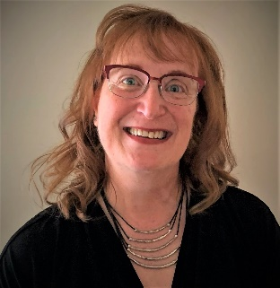
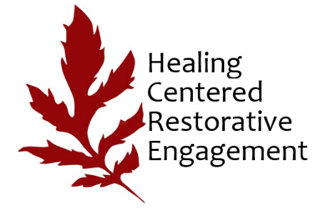

Dr. Tracy S. Hall’s wide range of expertise encompasses:
- higher education, nonprofit leadership and public institution administration;
- public policy and public affairs advocacy;
- legislative/regulatory processes;
- workforce development, career coaching, transition and navigation; and
- public administration & civil society-related research, teaching, service and praxis.

Her expertise is grounded in 40+ years of cross sectoral/boundary spanning experience, including service in the federal legislative and executive branches, as a higher education and nonprofit executive, and as a private sector government relations advisor and career coach.

Over the past 9+ years, Dr. Hall and Dr. Jess Camp have been co-developing an evidence-informed approach called Healing Centered Restorative Engagement (HCRE) that seeks to address trauma and toxic stress at the organizational, systems, and community levels. HCRE builds on such practices as restorative, healing centered engagement, and alternative administrative practices, among others. They provide consulting, educational, training, research, evaluation, and related support to organizations interested in finding a new way to support staff and clients on the path to well-being.

From 2009 to 2023 Dr. Hall was affiliated with the University of Michigan-Dearborn as both a lecturer in the Masters of Public Administration and Public Policy Program and as Executive Director of the Office of Metropolitan Impact (OMI). As a Lecturer II for 13 years in the UM-Dearborn Master of Public Administration and Public Policy program, she taught 7 different course subjects and roughly 500 students. In 2021, she received the American Society of Public Administrator’s Detroit Metropolitan Area award for being the outstanding scholar or practitioner engaged in educating future generations of public servants, and/or conducting research on matters relevant to good governance.

OMI was established to catalyze UM-Dearborn’s community engagement via research, teaching, learning, and service throughout Southeastern Michigan. From 2013-2015, Dr. Hall led a campus-wide effort that resulted in UM-Dearborn receiving the prestigious Carnegie Foundation for Teaching and Learning Engaged Campus elective classification and subsequently received the Michigan Campus Compact Engaged Campus of the Year award (2015). From 2013-2020, she led the successful grant applications that designated UM-Dearborn as the Operating Partner for the federally funded Public Allies Metro Detroit AmeriCorps national service program (see www.publicallies.org) targeting Opportunity Youth to serve in their own communities. Dr. Hall raised over $7.5 million in support of the Public Allies program and OMI’s community engagement programming.

Prior to her work at UM-Dearborn, Dr. Hall served from 2009-2011 as Director of Business Development & Operations for Corporation for a Skilled Workforce, which catalyzes change in educational and labor market systems, policies and practices to increase economic mobility, particularly for people of color and others historically excluded from success. From 2002-2009, she served on the executive leadership team of Focus: HOPE, a nationally renowned Detroit-based nonprofit engaged in civil/human rights and workforce development where she led agency-wide fundraising for its annual $28+ million operating budget, as well as public policy advocacy, community and volunteer outreach, communications and marketing, research and related activities.

Dr. Hall also served roughly 20 years in public service and government relations positions in the Greater Washington, D.C. Area, including appointments in the U.S. House of Representatives and as a political appointee for the 41st President of the United States.

Dr. Hall earned her Doctor of Philosophy (PhD) degree in public administration and public affairs from Virginia Polytechnic and State University (Virginia Tech) in 2006 and her Master of Public Administration (MPA) degree from The George Washington University in 1993. Proficient in Japanese, Hall received a Bachelor of Arts (BA) degree in Japanese Studies from Bucknell University in 1982, the junior year of which she spent at the International Christian University in Tokyo, Japan.

Dr. Hall actively participates in professional and academic activities related to:
- informing national policy and practices related to trauma, toxic stress, alternative administrative practices, and their effects on marginalized populations;
- public administration & policy;
- the nonprofit sector;
- community/civic engagement, social entrepreneurship and civil society;
- post-secondary community engagement;
- Detroit’s urban renewal and revitalization; as well as
- talent management and workforce development, particularly about Opportunity Youth and marginalized communities.

Dr. Hall’s primary interest is to engage in both theory and practice that lead to positive transformational social change.

